**Here are the feedbacks on my test analysis, executing the journeys from both API and UI:**

1. I searched for 'Nike React Phantom Run Flyknit 2', and it worked properly in both the UI and the API. Additionally, I searched for 'Nike React Infinity Run Flyknit' via the API, and it is also working as expected.
2. When I select the small-sized black color, it works properly in both the UI and the API. However, when I select the quantity of products I want to buy, it works properly on the UI, but through the API, it returns a '400 Bad Request' error due to a server issue.

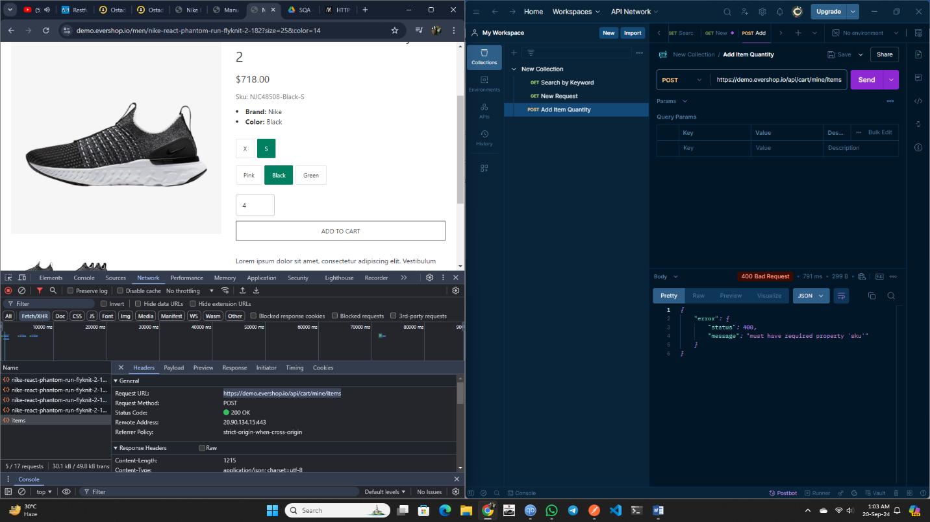

Then, when I submit raw data {"sku": "NJC48508-Black-S", "qty": "4"} in the request body, it works properly. However, one issue remains: whenever I enter the quantity and press 'Enter', the new quantity is added to the previous one instead of replacing it.

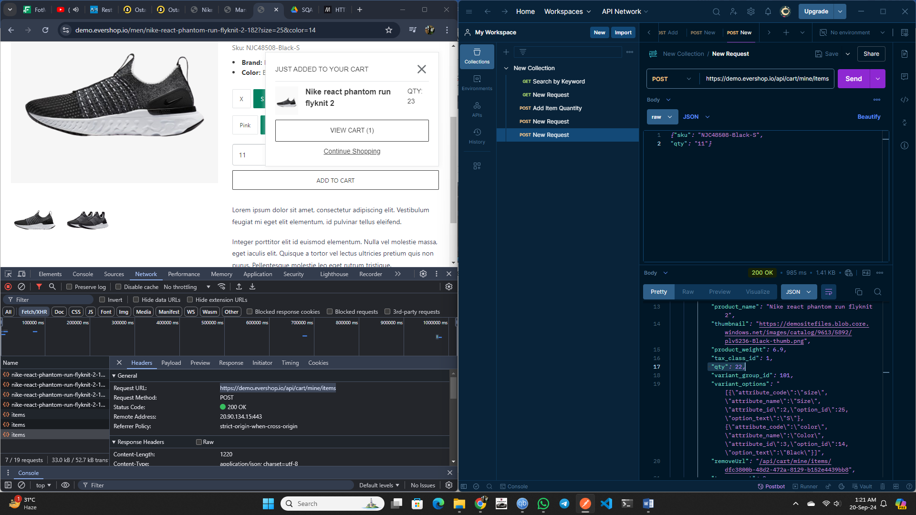

1. In the cart view, when I reduce the quantity of a product, it works properly in the UI. However, in the API, it returns a '500 Internal Server Error'.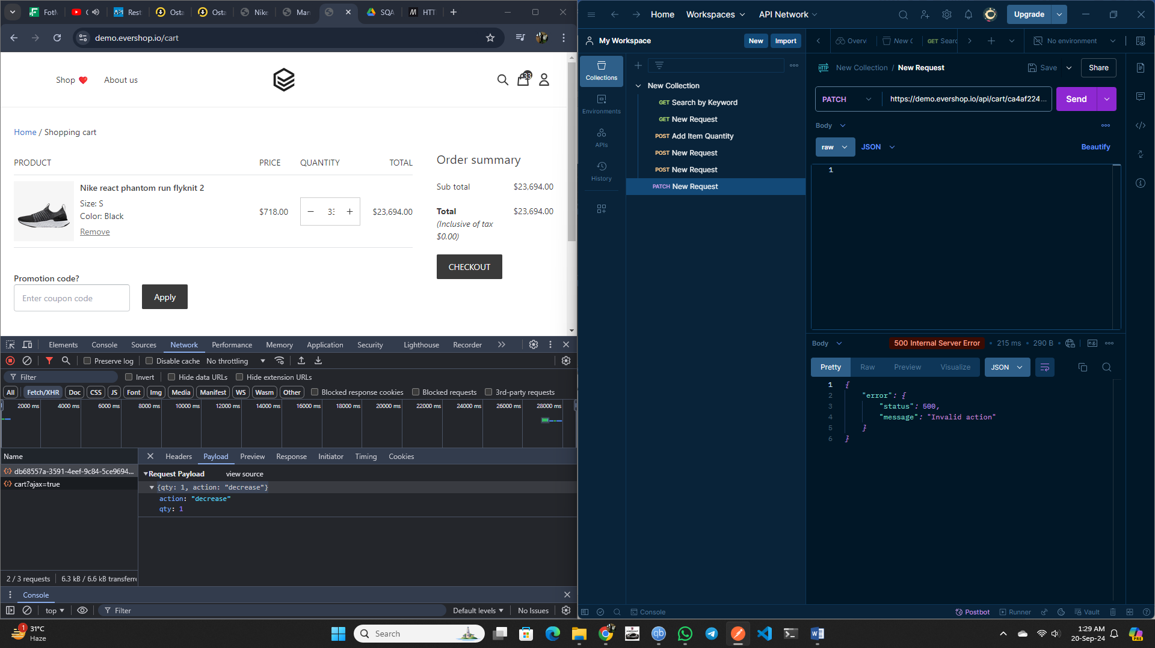

However, when I submit the raw data {"qty": 1, "action": "decrease"} in the request body, it works properly.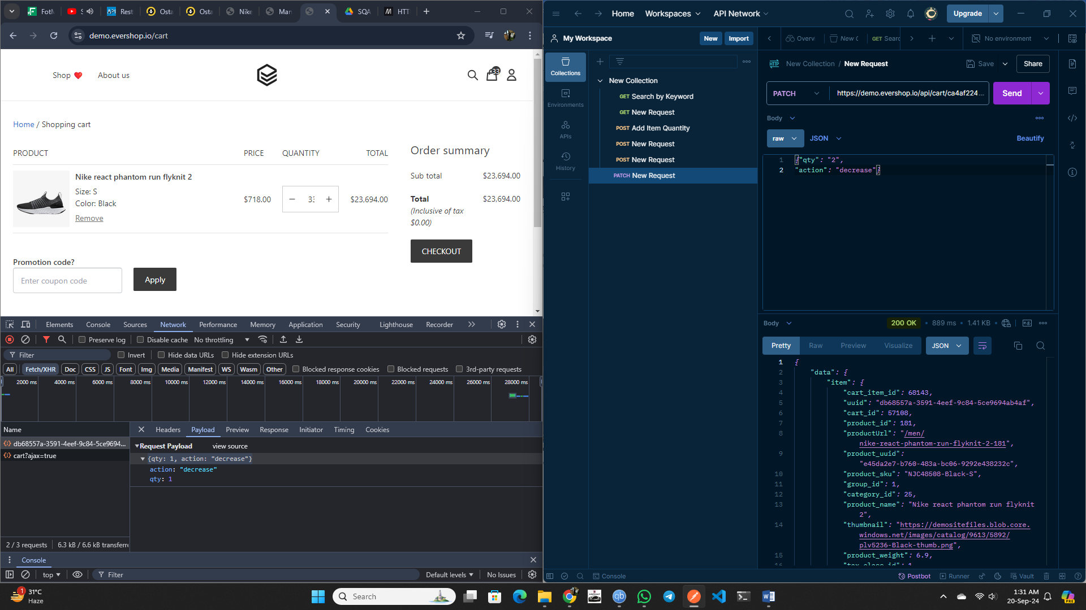

1. After clicking the checkout button, it works properly on both the UI and the API.
2. When I remove an item from the cart, it works properly in the UI. However, through the API, it returns a '500 Internal Server Error'.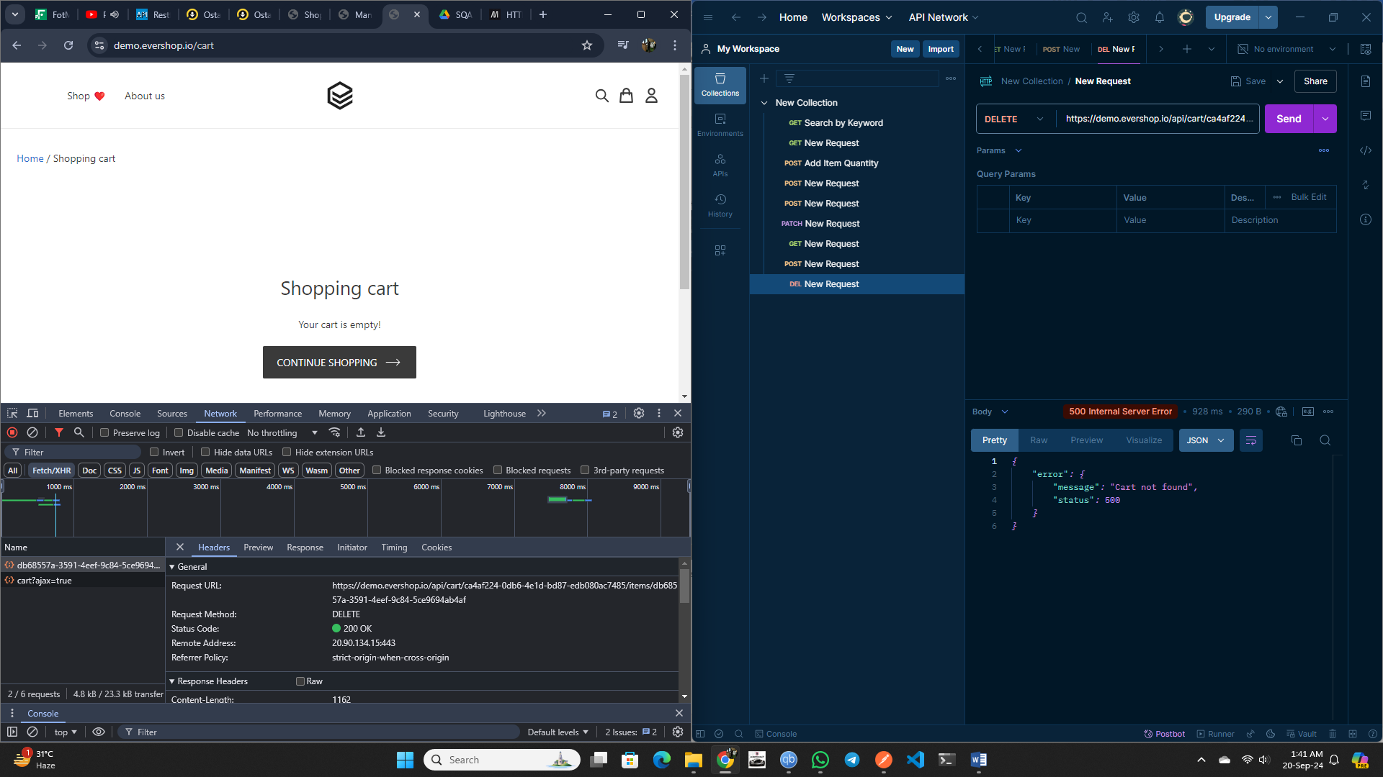
3. When I add a random coupon in the coupon box and click 'Apply', the UI displays the message 'Invalid coupon'. In the API, it returns a '500 Internal Server Error', which I think is correct in this case.